Concept Review

Sensor Noise

How to interpret sensor data?

# Many types of sensors exist for observing various physical properties of the world around us: encoders measure position, accelerometers measure acceleration, thermocouples measure temperature, and the list goes on. What all sensors have in common is that they all contain some amount of error in their measured outputs. Random time-varying errors in a sensor’s output signal are typically called ‘sensor noise.’ Sensor noise is caused primarily by electrical interference, although quantization errors (caused by converting analog signals to a digital-representation) also play a role. This document discusses how to interpret sensor data and model sensor noise.

Additive Gaussian White Noise

For most real-world systems, the random variations in a sensor's output signal are well modelled as additive Gaussian white noise. The term additive means that a sensor’s output ($y_{m}$) is a summation of two terms: the true signal being measured ($y$), and a random noise term ($w$).

$$y_{m}=y+w$$

As a random variable, the noise term (in this case $w$) is assumed to be normally distributed, having a probability density function in the shape of a Gaussian function (commonly referred to as a bell curve and shown in fig. 1).

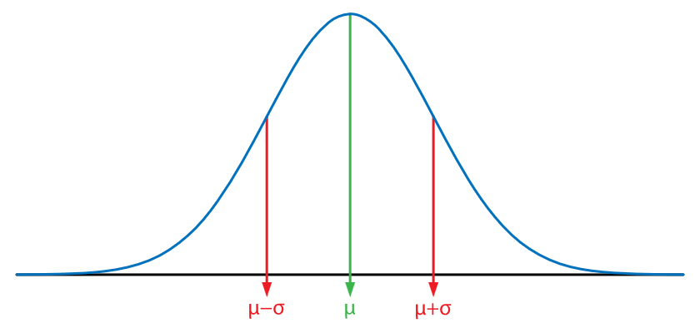

Figure 1: Gaussian function with relevant parameters highlighted.

The equation for a Guassian curve is determined by two parameters ( $μ$ and $σ$) and is defined as follows:

$$g\left(x\right)=\frac{1}{σ\sqrt{2π}}exp\left(-\frac{1}{2}\frac{{\left(x-μ\right)}^{2}}{σ^{2}}\right)$$

$μ$ represents the mean and defines the centre location of the curve (the point with the highest probability). $σ$ is referred to as the ‘standard deviation’ and quantifies the level of variation, or width of the curve. Figure 2 shows how variations in $μ$ and $σ$ affect the resulting curve produced.

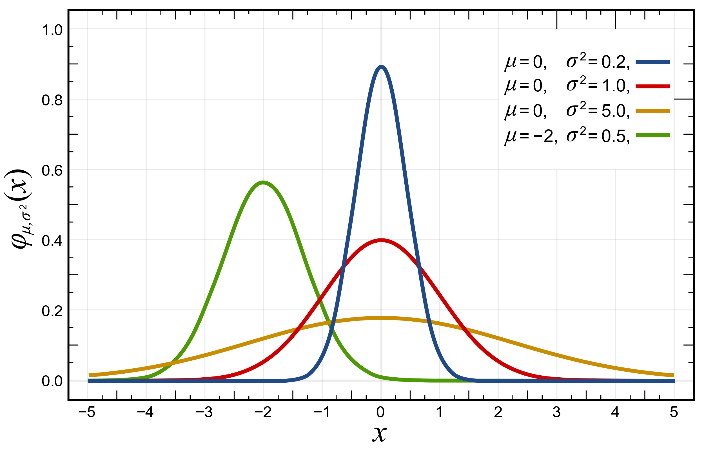

Figure 2: Gaussian functions with various parameter values.

Estimating Noise Parameters from Sensor Data

Figure 3 shows a sample recording of 30 seconds of measurements from two accelerometers, one orientated vertically, and one oriented horizontally. The accelerometers where sitting stationary on a table for the duration of the recording process. In these two plots, the presence of noise is clearly visible as the random gitters in what should otherwise be a constant value. By plotting the histogram of the recorded data (fig 4.), it can be seen that the captured data does indeed appear to be normally distributed.

|  |  |
| --- | --- |
|  |  |

Figure 3: Accelerometer measurements over time.

|  |  |
| --- | --- |
|  |  |

Figure 4: Histograms from measured accelerometer data, fitted to normal distributions.

Given the recorded sensor data, we can identify the shape of the underlying distribution by estimating the two parameters that define a gaussian function: $μ$ and $σ$. The mean $μ$ can be calculated as follows:

$$μ=\frac{1}{N}\sum_{i=1}^{N}{y_{m,i}}$$

where $y_{m,i}$ denotes the $i$ th data sample and $N$ is the number of samples recorded. Once the mean has been calculated, the standard deviation can be calculated as follows:

$$σ=\sqrt{\frac{1}{N}\sum_{i=1}^{N}{{\left(y_{m, i}-μ\right)}^{2}}}$$

For the recorded accelerometer data shown in fig. 3, the identified Gaussian noise profiles are plotted in fig. 4 overtop of the histogram.

© 2022 Quanser Inc., All rights reserved.

Quanser Inc.

119 Spy Court

Markham, Ontario

L3R 5H6

Canada

info@quanser.com

Phone: 19059403575

Fax: 19059403576

Printed in Markham, Ontario.

For more information on the solutions Quanser Inc. offers, please visit the web site at: <http://www.quanser.com>

This document and the software described in it are provided subject to a license agreement. Neither the software nor this document may be used or copied except as specified under the terms of that license agreement. Quanser Inc. grants the following rights: a) The right to reproduce the work, to incorporate the work into one or more collections, and to reproduce the work as incorporated in the collections, b) to create and reproduce adaptations provided reasonable steps are taken to clearly identify the changes that were made to the original work, c) to distribute and publicly perform the work including as incorporated in collections, and d) to distribute and publicly perform adaptations. The above rights may be exercised in all media and formats whether now known or hereafter devised. These rights are granted subject to and limited by the following restrictions: a) You may not exercise any of the rights granted to You in above in any manner that is primarily intended for or directed toward commercial advantage or private monetary compensation, and b) You must keep intact all copyright notices for the Work and provide the name Quanser Inc. for attribution. These restrictions may not be waved without express prior written permission of Quanser Inc.